Asimov: The Unauthorized Life, Michael White, Millennium First Ed UK publication 1994, Dust jacket is unclipped and the price is 17.99 pounds. The as new (never read) hardcover book has 277 pages all bound tightly without a mark of any kind
Biography of the science fiction and popular science writer. As well as his personal life, it gives the background to the creation of many of his most popular works, such as 'The Foundation Series(Foundation, Foundation and Empire, Second Foundation etc), the stories that became ' I, Robot' & single novels such as 'The Gods Themselves' & 'The End of Eternity'
The word 'unauthorised' in the title has been spelt with a 'z' rather than a 's' on the Dust Jacket and on the boards. On the title page, however it is spelt with an 's'.
ID 000188 Price $25 Box 2
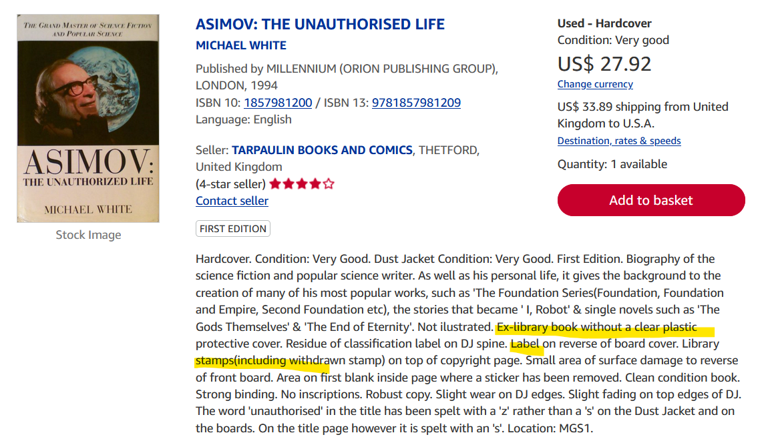

Amazon new $55

